Lab Experiments
Question:
1. Create a simple cloud software application for Flight Reservation System using any Cloud
Service Provider to demonstrate SaaS include the necessary fields such as one way, round
trip, From, to, Departure, Departure, Travelers &amp; Class, Fare Type, International and
Domestic Flights etc.
Answer:
FLIGHT RESERVATION SYSTEM USING ZOHO CREATOR
AIM
To create a simple cloud-based Flight Reservation System using Zoho Creator as a Software as a Service (SaaS) platform. The application allows users to enter flight reservation details such as trip type, source, destination, departure date, travelers, travel class, fare type, and domestic or international flight type.
PROCEDURE
- Open Zoho Creator and sign in to the account.
- Create a new application named Flight Reservation System.
- Create a form to collect the required flight reservation details.
- Add a Trip Type field with options such as One Way and Round Trip.
- Add From and To fields to enter the departure and destination locations.
- Add a Departure Date field and, if required, a Return Date field for round-trip bookings.
- Add a Travelers & Class section to enter the number of travelers and select the travel class such as Economy, Premium Economy, or Business.
- Add a Fare Type field to select the required fare category.
- Add a Flight Type field with options such as Domestic and International.
- Arrange the fields properly and design the form using Zoho Creator's application builder.
- Save and publish the application so that it can be accessed through the cloud.
- Test the application by entering sample flight reservation details and submitting the form.
- Verify that the submitted reservation details are stored in the Zoho Creator cloud database.
OUTCOME
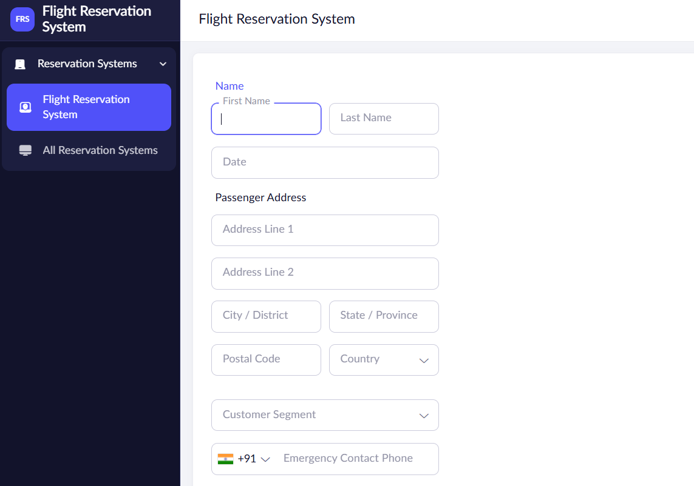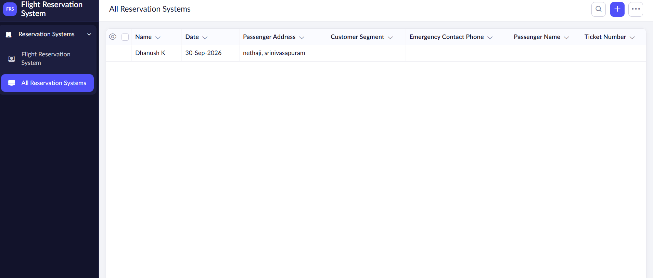

RESULT
Thus, a simple cloud-based Flight Reservation System was successfully created using Zoho Creator. The application provides the required fields for one-way and round-trip flights, source and destination, departure and return dates, travelers and class, fare type, and domestic or international flights. The system demonstrates the SaaS concept by allowing the application to be created, accessed, and managed through the cloud without requiring local server installation.
Question:
2. Create a simple cloud software application for Property Buying &amp; Rental process (In Chennai city) using any Cloud Service Provider to demonstrate SaaS include the necessary fields such as Buy, Rent, commercial, Rental Agreement , Rental Agreement, Area, place, Range, property value etc.
Answer:
PROPERTY BUYING & RENTAL SYSTEM USING ZOHO CREATOR
AIM
To create a simple cloud-based Property Buying and Rental System for Chennai city using Zoho Creator as a Software as a Service (SaaS) platform. The application allows users to enter and manage property details such as Buy or Rent, Commercial or Residential property, rental agreement, area, place, property range, and property value.
PROCEDURE
- Open Zoho Creator and sign in to the account.
- Create a new application named Property Buying & Rental System.
- Create a form to collect the required property details.
- Add a Process Type field with options such as Buy and Rent.
- Add a Property Type field with options such as Residential and Commercial.
- Add an Area field to enter the size of the property in square feet.
- Add a Place field to enter the location of the property in Chennai, such as Tambaram, Velachery, Guindy, or Anna Nagar.
- Add a Price Range field to specify the expected property price or rental range.
- Add a Property Value field to enter the total value of the property.
- Add a Rental Agreement field to specify whether a rental agreement is required for rental properties.
- Add other necessary fields such as Owner Name, Contact Number, Address, and Property Description.
- Arrange and design the fields properly using the Zoho Creator application builder.
- Save and publish the application so that it can be accessed through the cloud.
- Enter sample property details and submit the form to test the application.
- Verify that the submitted property information is stored and managed in the Zoho Creator cloud database.
OUTCOME
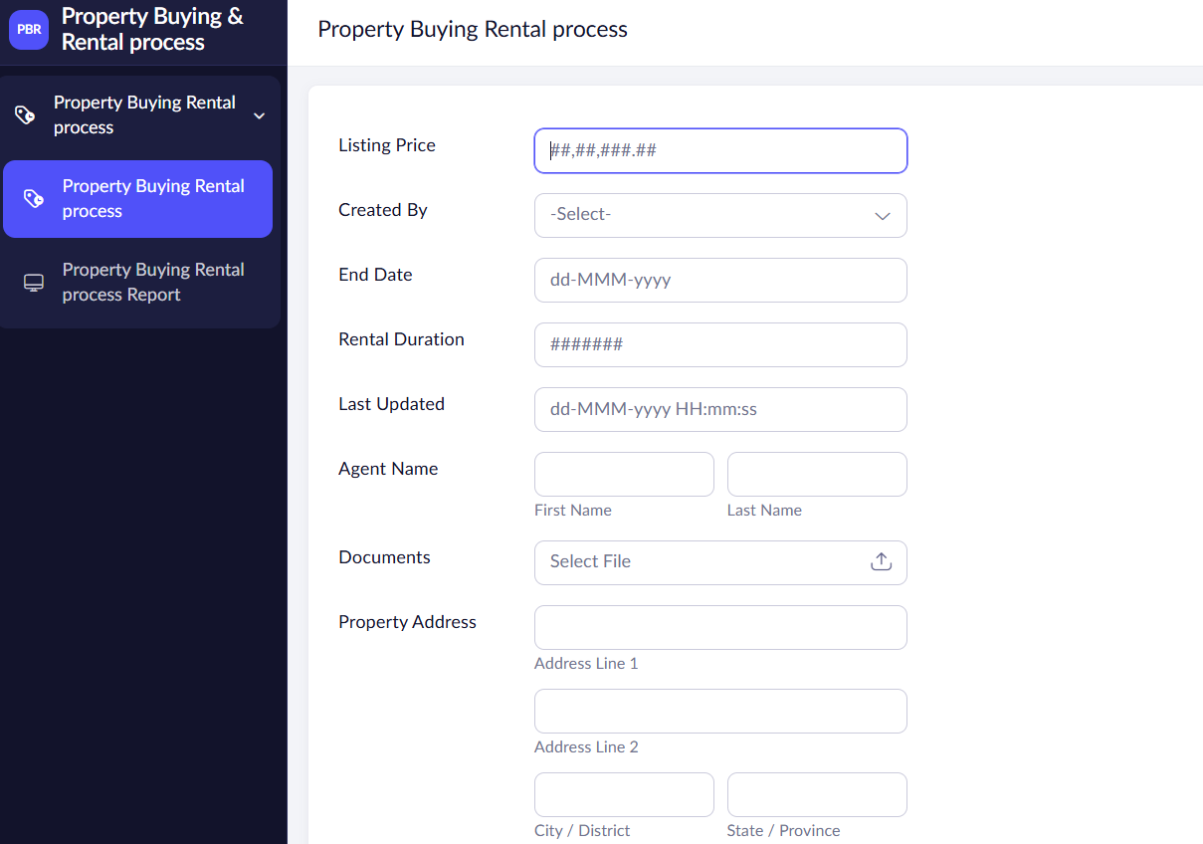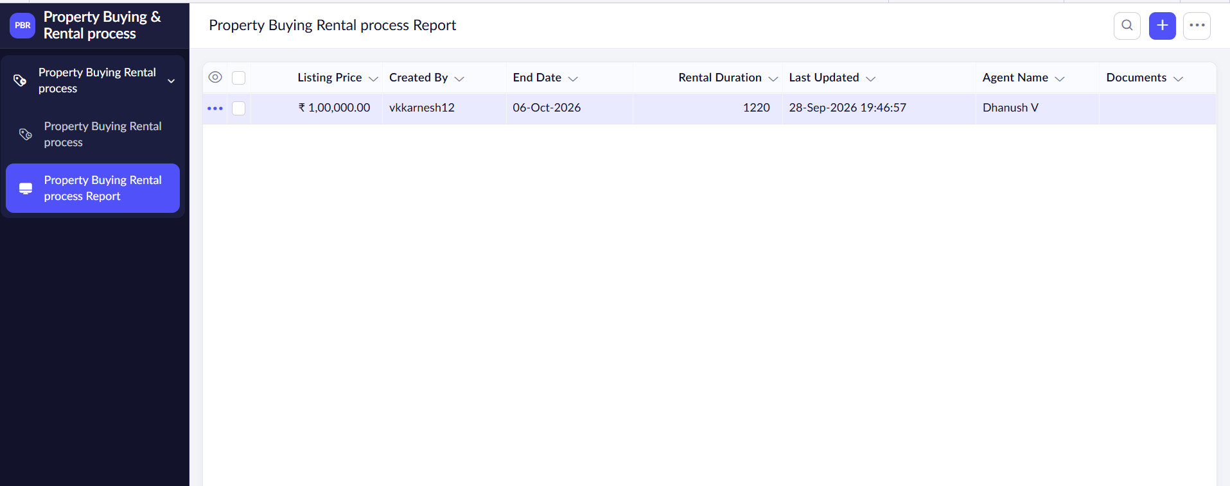

RESULT
Thus, a simple cloud-based Property Buying & Rental System for Chennai city was successfully created using Zoho Creator. The application supports property buying and rental processes and includes details such as Buy/Rent, Residential/Commercial, Rental Agreement, Area, Place, Price Range, and Property Value. The application demonstrates the SaaS concept by providing cloud-based access and management of property information.
Question:
3. Create a simple cloud software application for Car Booking Reservation System using any
Cloud Service Provider to demonstrate SaaS include the necessary fields such as search for
cabs, from, to, rental , out station, Package type, hours/Days etc.
Answer:
AIM
To create a simple cloud-based Car Booking Reservation System using Zoho Creator as a Software as a Service (SaaS) platform. The application allows users to search for cabs and enter booking details such as From, To, Rental, Out Station, Package Type, and Hours/Days.
PROCEDURE
- Open Zoho Creator and sign in to the account.
- Create a new application named Car Booking Reservation System.
- Create a form to collect the required car booking details.
- Add a Search for Cabs field to select or search for available cabs.
- Add From and To fields to enter the pickup and destination locations.
- Add a Booking Type field with options such as Rental and Out Station.
- Add a Package Type field to select the required cab package.
- Add Hours/Days fields to specify the booking duration.
- Add Date, Time, Customer Name, and Contact Number fields.
- Arrange the fields properly using the Zoho Creator application builder.
- Save and publish the application so that it can be accessed through the cloud.
- Enter sample booking details and submit the form to test the application.
- Verify that the submitted booking details are stored in the Zoho Creator cloud database.
Output:
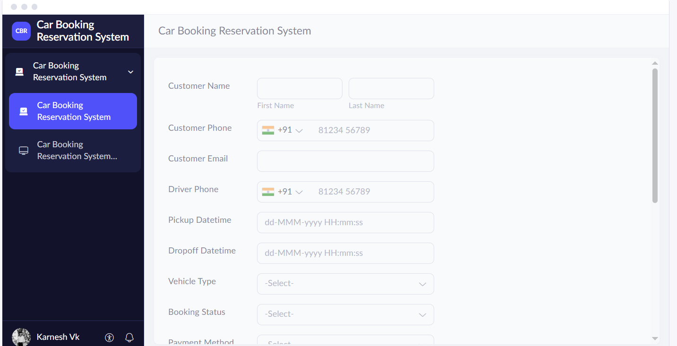

Result:
Thus, a simple cloud-based Car Booking Reservation System was designed using Zoho Creator to demonstrate SaaS. The application helps users enter and manage cab reservation details through the cloud.
Question:
4. Create a simple cloud software application for Library book reservation system for SIMATS
library using any Cloud Service Provider to demonstrate SaaS include the necessary fields
such as Title of the book, author, publications, Year, edition, no of copies, Rack no, status
(taken/returned) etc.
Answer:
AIM
To create a simple cloud-based Library Book Reservation System for SIMATS Library using Zoho Creator as a SaaS platform. The application manages book details such as title, author, publication, year, edition, number of copies, rack number, and status.
PROCEDURE
- Open Zoho Creator and sign in to the account.
- Create a new application named SIMATS Library Book Reservation System.
- Create a form to collect book details.
- Add a Title of the Book field.
- Add Author and Publication fields.
- Add Year and Edition fields.
- Add a Number of Copies field.
- Add a Rack Number field to identify the book's location.
- Add a Status field with options such as Taken and Returned.
- Add Student Name and Register Number fields for reservation details.
- Arrange the fields using the application builder.
- Save and publish the application.
- Enter sample book details and verify that the information is stored in the cloud database.
Outcome:
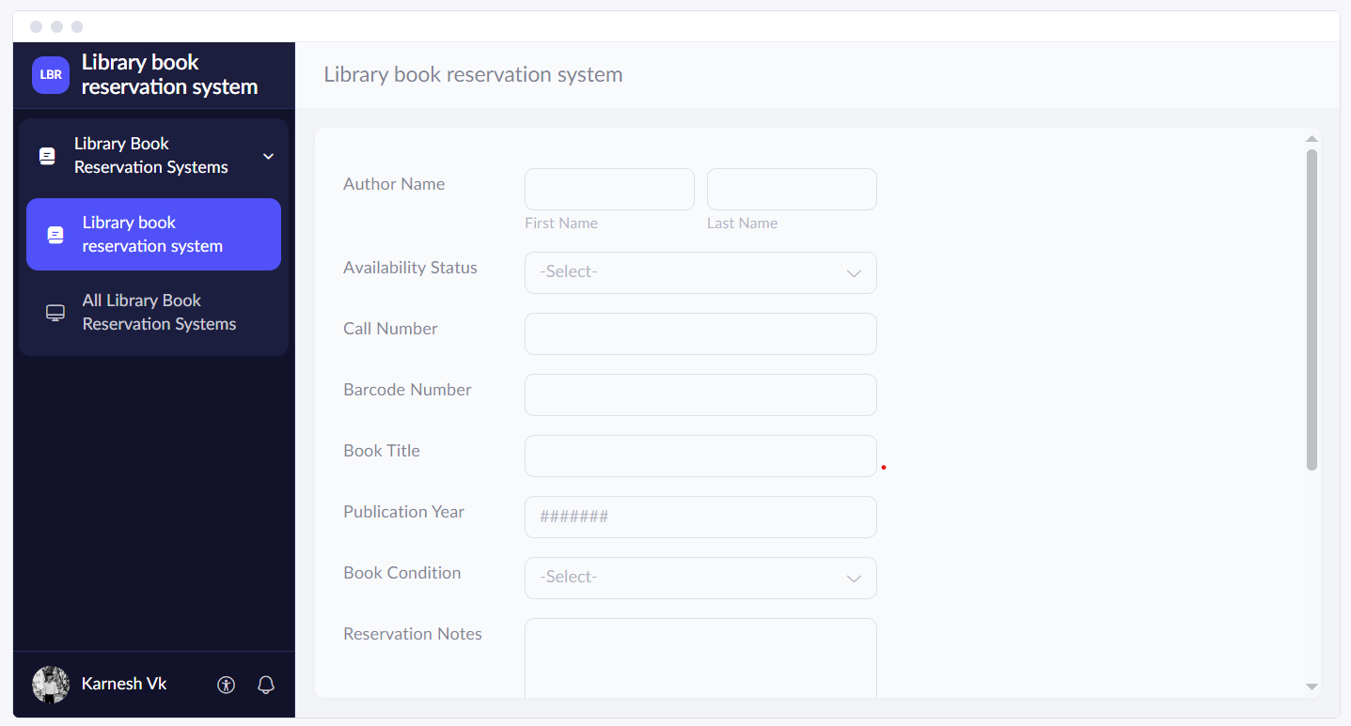
Result:
Thus, a simple cloud-based Library Book Reservation System for SIMATS Library was designed using Zoho Creator to demonstrate SaaS. The application helps manage library books and reservation records through the cloud.
Question:
5. Create a simple cloud software application for Mark Sheet Processing System using any
Cloud Service Provider to demonstrate SaaS include the necessary fields such as name of the
student, Reg no of the student , Subjects , Marks, Average, percentage, rank, overall
performance etc.
Answer:
AIM
To create a simple cloud-based Mark Sheet Processing System using Zoho Creator as a SaaS platform. The application processes student details, subject marks, average, percentage, rank, and overall performance.
PROCEDURE
- Open Zoho Creator and sign in to the account.
- Create a new application named Mark Sheet Processing System.
- Create a form to collect student and examination details.
- Add Student Name and Register Number fields.
- Add Subject fields to enter subject names.
- Add Marks fields to record marks obtained in each subject.
- Add an Average field to calculate average marks.
- Add a Percentage field to calculate the percentage of marks.
- Add a Rank field to record the student's rank.
- Add an Overall Performance field with options such as Excellent, Good, Average, and Needs Improvement.
- Configure suitable formulas for average and percentage calculations.
- Arrange the fields properly.
- Save and publish the application.
- Enter sample marks and verify the calculated results.
Output:
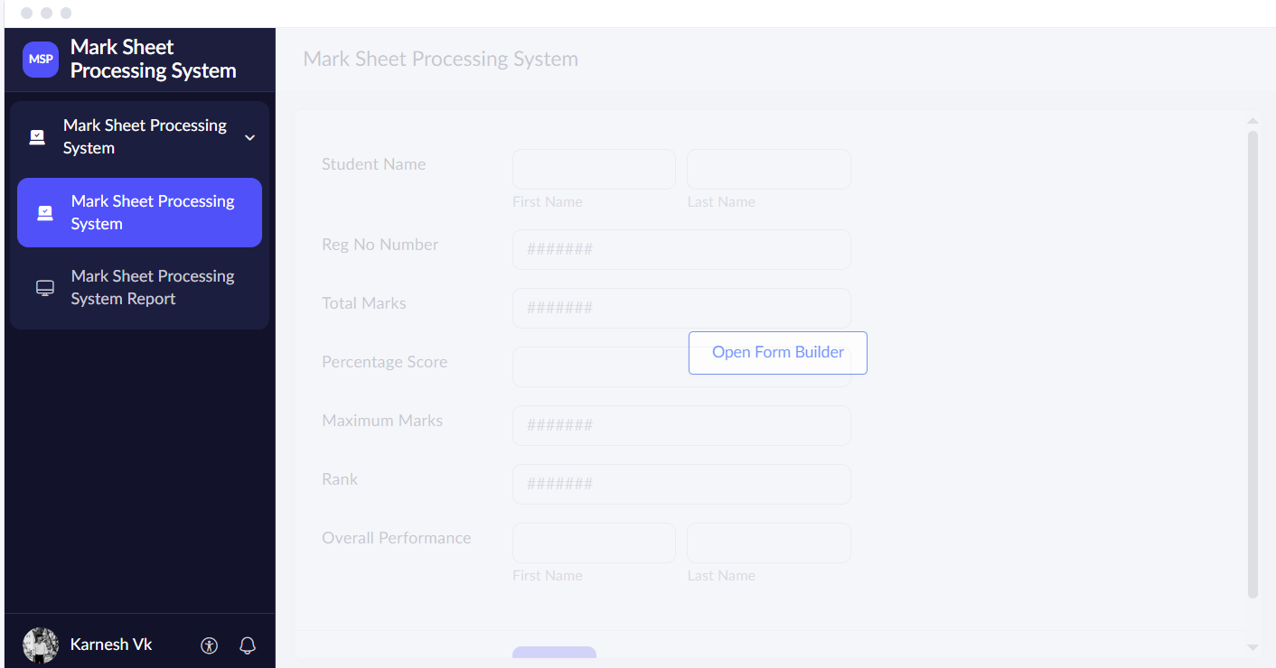
RESULT
Thus, a simple cloud-based Mark Sheet Processing System was designed using Zoho Creator to demonstrate SaaS. The application helps process student marks and maintain academic performance records through the cloud.
Question:
6. Create a simple cloud software application for Payroll Processing System using any Cloud
Service Provider to demonstrate SaaS include the necessary fields such as Name of the
employee, experience in present org , over all experience, basic pay, HRA, DA, TA, net pay,
gross pay etc.
Answer:
AIM
To create a simple cloud-based Payroll Processing System using Zoho Creator as a SaaS platform. The application manages employee details, experience, basic pay, HRA, DA, TA, gross pay, and net pay.
PROCEDURE
- Open Zoho Creator and sign in to the account.
- Create a new application named Payroll Processing System.
- Create a form to collect employee and salary details.
- Add a Name of the Employee field.
- Add Experience in Present Organization and Overall Experience fields.
- Add a Basic Pay field.
- Add an HRA field for House Rent Allowance.
- Add a DA field for Dearness Allowance.
- Add a TA field for Travel Allowance.
- Add a Gross Pay field to calculate total salary before deductions.
- Add deduction fields such as PF and tax, if required.
- Add a Net Pay field to calculate salary after deductions.
- Configure suitable salary calculation formulas.
- Save and publish the application.
- Enter sample employee salary details and verify the calculations.
Output:
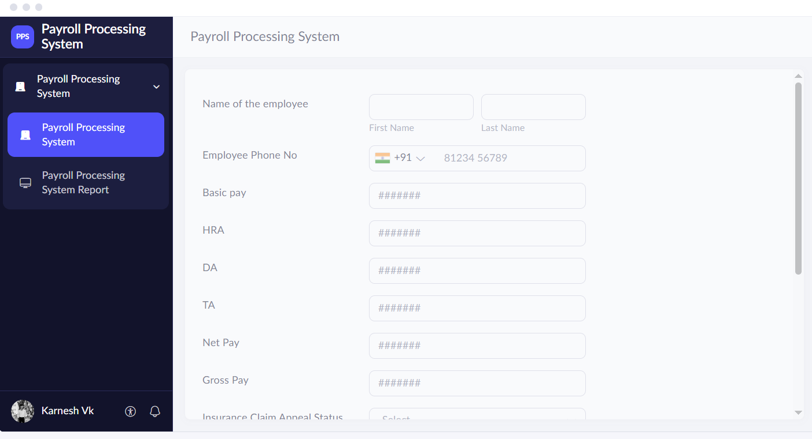
RESULT
Thus, a simple cloud-based Payroll Processing System was designed using Zoho Creator to demonstrate SaaS. The application helps maintain employee salary details and calculate payroll through the cloud.

Question:
7. Create a simple cloud software application for Students Attendance System using any Cloud
Service Provider to demonstrate SaaS include the necessary fields such as name of the
students, course, present , Absent, course attendance, OD request, grade, attendance
percentage, etc.
Answer:
AIM
To create a simple cloud-based Students Attendance System using Zoho Creator as a SaaS platform. The application manages student names, courses, present and absent status, course attendance, OD requests, grades, and attendance percentage.
PROCEDURE
- Open Zoho Creator and sign in to the account.
- Create a new application named Students Attendance System.
- Create a form to collect student and attendance details.
- Add a Student Name field.
- Add a Register Number field.
- Add a Course field to select the course name.
- Add an Attendance Status field with Present and Absent options.
- Add a Course Attendance field to record attendance for each course.
- Add an OD Request field to record On-Duty requests.
- Add an Attendance Percentage field.
- Add a Grade field to record the attendance grade, if required.
- Configure the attendance percentage calculation.
- Save and publish the application.
- Enter sample attendance details and verify the stored records.

Output:
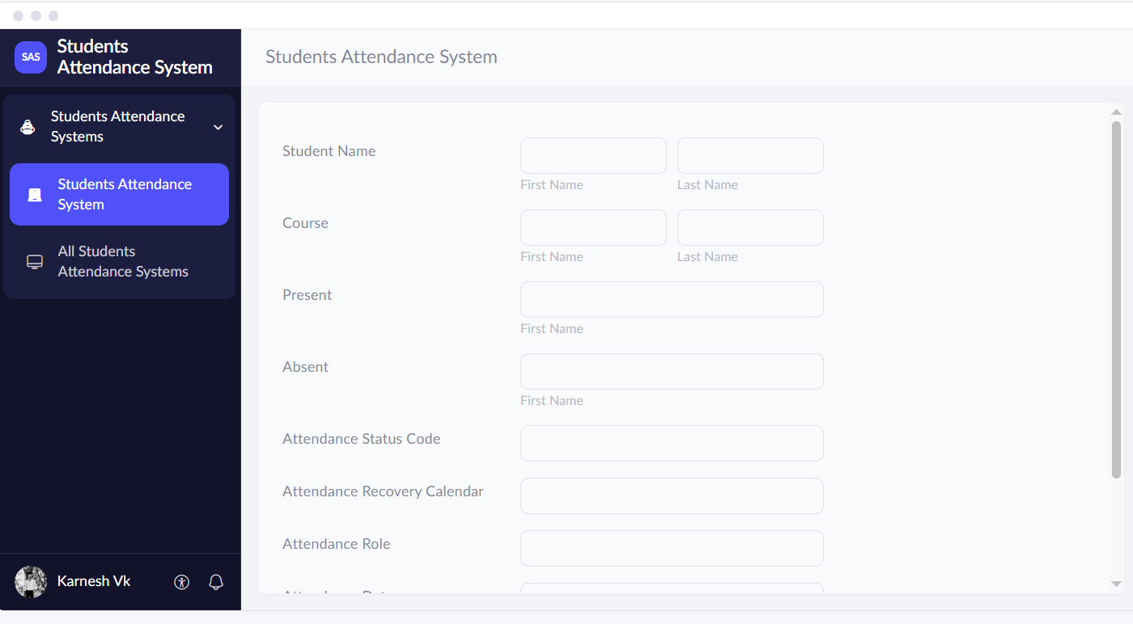
RESULT
Thus, a simple cloud-based Students Attendance System was designed using Zoho Creator to demonstrate SaaS. The application helps maintain attendance records and monitor students' attendance percentages through the cloud.

Question:
8. Create a simple cloud web application for student counselling system using any Cloud
Service Provider to demonstrate SaaS with the fields of student name, age, address, phone,
subjects studied, Year of passing, percentage of marks, domain interest, etc.
Answer:
AIM
To create a simple cloud-based Student Counselling System using Zoho Creator as a SaaS platform. The application collects student personal details, educational qualifications, marks percentage, and domain interests to support counselling activities.
PROCEDURE
- Open Zoho Creator and sign in to the account.
- Create a new application named Student Counselling System.
- Create a form to collect personal and educational details.
- Add a Student Name field.
- Add an Age field.
- Add an Address field.
- Add a Phone Number field.
- Add a Subjects Studied field.
- Add a Year of Passing field.
- Add a Percentage of Marks field.
- Add a Domain Interest field with options such as Artificial Intelligence, Data Science, Web Development, and Cybersecurity.
- Add a Counselling Remarks field to record guidance provided.
- Arrange the fields properly.
- Save and publish the application.
- Enter sample student details and verify that the information is stored in the cloud database.
Output:
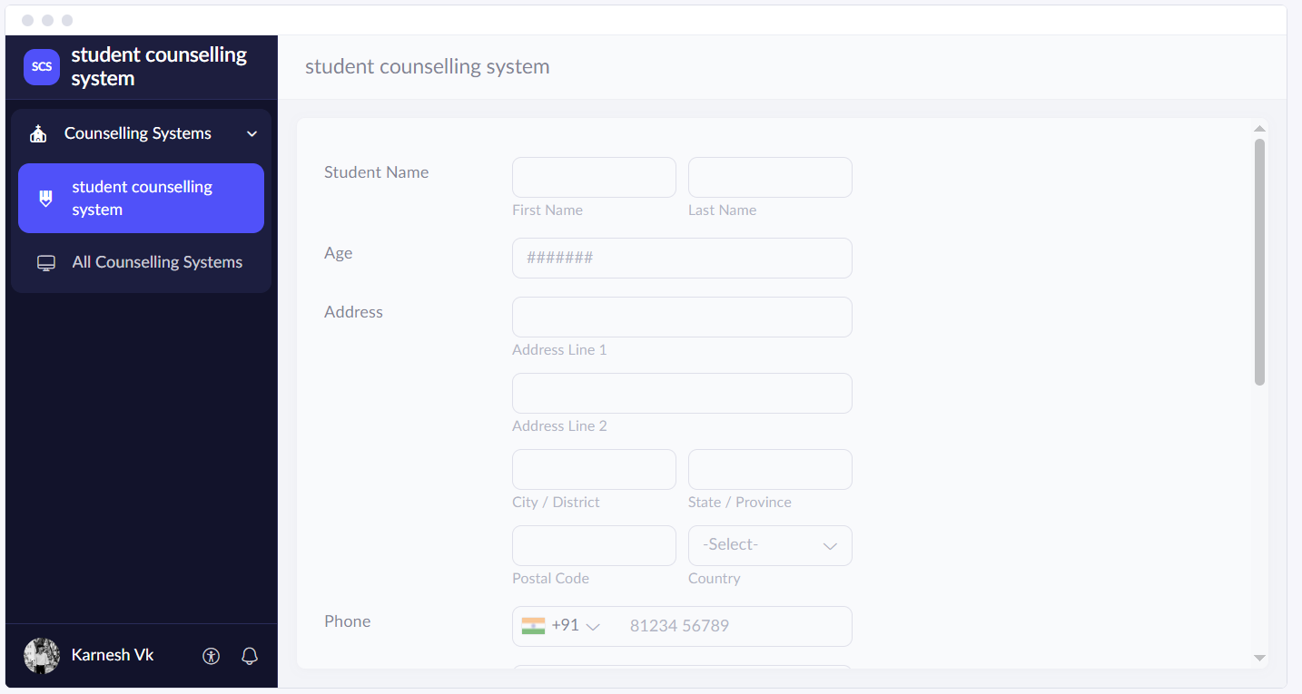
RESULT
Thus, a simple cloud-based Student Counselling System was designed using Zoho Creator to demonstrate SaaS. The application helps maintain student information and support educational and career counselling activities through the cloud.

Question:
9. Create a simple cloud software application for Hospital information system for SIMATS
Hospital using any Cloud Service Provider to demonstrate SaaS with fields of patient name,
age, address, phone, email, Attender name, attender phone, doctor name, diseases, etc.
Answer:
AIM
To create a simple cloud-based Hospital Information System for SIMATS Hospital using Zoho Creator as a SaaS platform. The application manages patient information, contact details, attender details, doctor names, and disease information.
PROCEDURE
- Open Zoho Creator and sign in to the account.
- Create a new application named SIMATS Hospital Information System.
- Create a form to collect patient information.
- Add a Patient Name field.
- Add an Age field.
- Add an Address field.
- Add Phone Number and Email fields.
- Add an Attender Name field.
- Add an Attender Phone Number field.
- Add a Doctor Name field.
- Add a Diseases field to record the patient's reported disease or diagnosis.
- Add additional fields such as Patient ID, Appointment Date, and Department, if required.
- Arrange the fields properly.
- Save and publish the application.
- Enter sample patient details and verify that the information is stored in the cloud database.
Output:
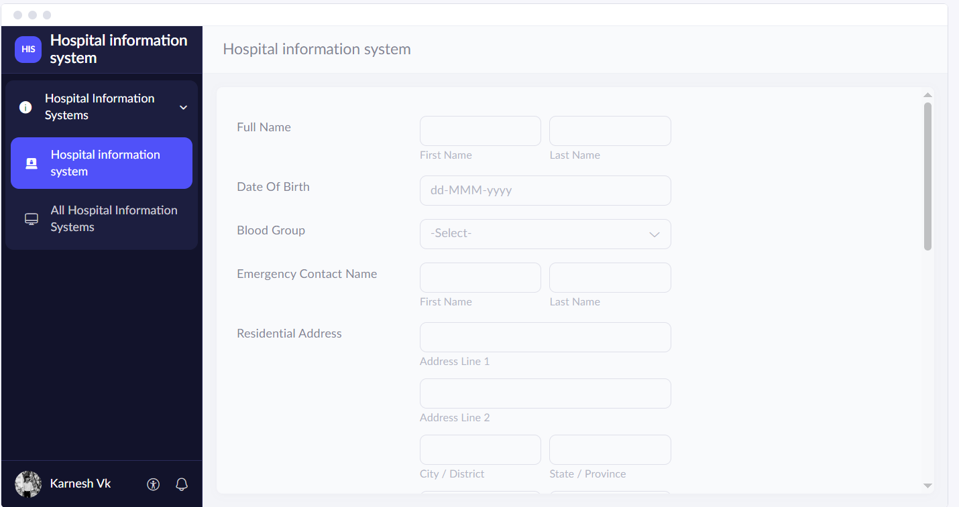
RESULT
Thus, a simple cloud-based Hospital Information System for SIMATS Hospital was designed using Zoho Creator to demonstrate SaaS. The application helps maintain patient and hospital information through the cloud. Patient information should be accessible only to authorized users.

Question:
10. Create a simple cloud software application to run a c program to display the student
information using any Cloud Service Provider to demonstrate SaaS with the template of
student name, reg no, address, phone, age, courses, grades and attendance report, progress
report, Semester mark sheet forms
Answer:
AIM
To create a simple Student Information System using a C program on a cloud-based development platform to demonstrate cloud software access. The application displays student name, register number, address, phone, age, courses, grades, attendance report, progress report, and semester mark sheet.
PROCEDURE
- Open a cloud-based development platform that supports C programming.
- Create a new C program named Student Information System.
- Include the required header file, such as stdio.h.
- Declare variables to store student name, register number, address, phone number, age, courses, and grades.
- Write a function to accept student information from the user.
- Write a function to display the entered student details.
- Add fields to record the student's attendance report.
- Add fields to display the student's academic progress report.
- Create a semester mark sheet section to display subject marks and grades.
- Compile the C program and correct any errors.
- Run the program and enter sample student details.
- Verify that student information, attendance, progress, and semester marks are displayed correctly.
- Save the program on the cloud platform and share it if the platform supports sharing.
Output:
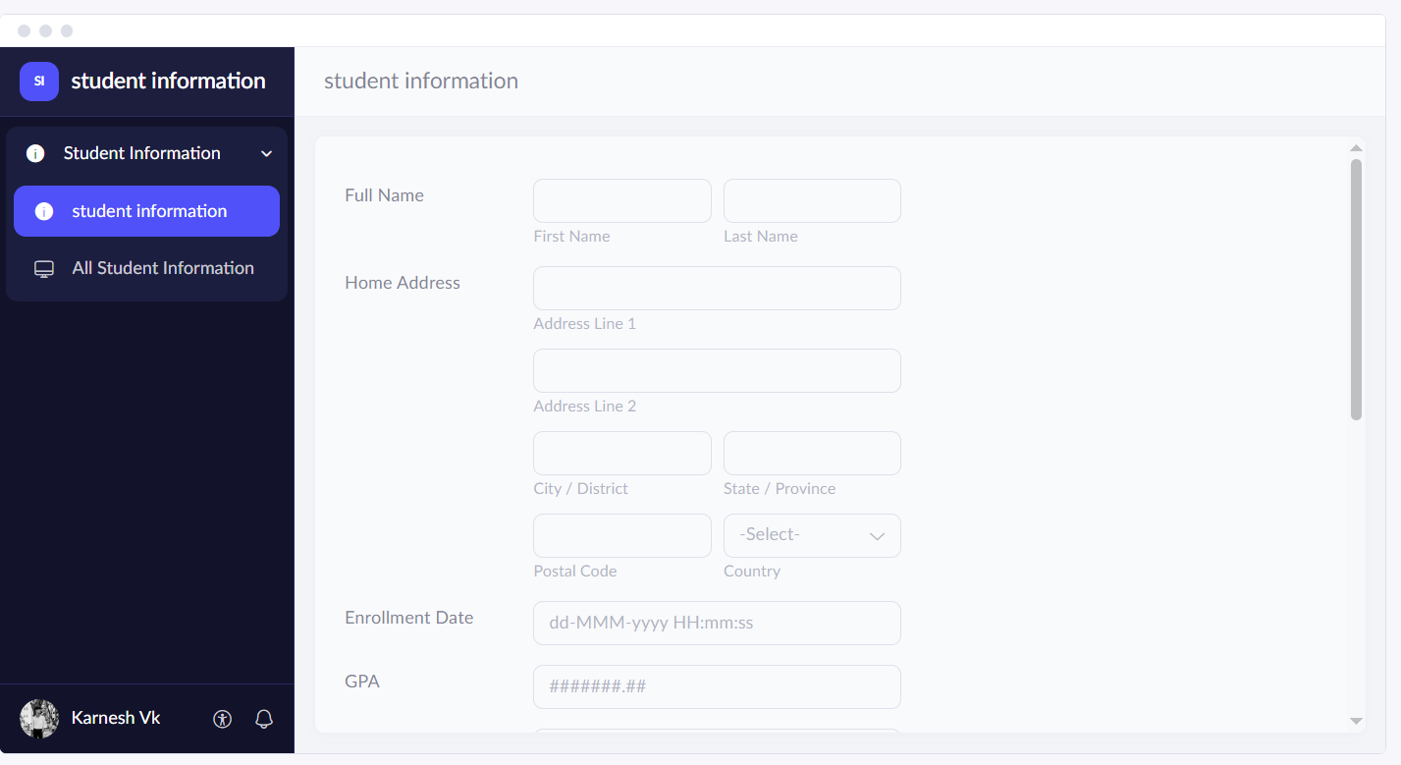
RESULT
Thus, a simple Student Information System was developed using a C program on a cloud-based development platform. It demonstrates running software through a cloud service. A complete SaaS application may additionally require a web interface and persistent data storage.
Question:
11. Create a simple cloud software application for online super market using any Cloud Service
Provider to demonstrate SaaS with the template of customer name, address, phone, email,
items, quantity etc. with the item classification form.
Answer:
AIM
To create a simple cloud-based Online Supermarket application using Zoho Creator as a SaaS platform. The application manages customer details, address, phone, email, items, quantities, and item classification.
PROCEDURE
- Open Zoho Creator and sign in to the account.
- Create a new application named Online Supermarket System.
- Create a Customer Details form.
- Add a Customer Name field.
- Add an Address field.
- Add Phone Number and Email fields.
- Create an Item Details form to manage supermarket products.
- Add an Item Name field.
- Add an Item Classification field with options such as Groceries, Fruits, Vegetables, Dairy Products, Beverages, and Household Items.
- Add a Quantity field.
- Add a Price field to record the item price.
- Add Order Date and Order Status fields, if required.
- Arrange the fields properly.
- Save and publish the application.
- Enter sample customer and item details and submit an order.
- Verify that the customer information, item classification, and order details are stored in the cloud database.

Output:
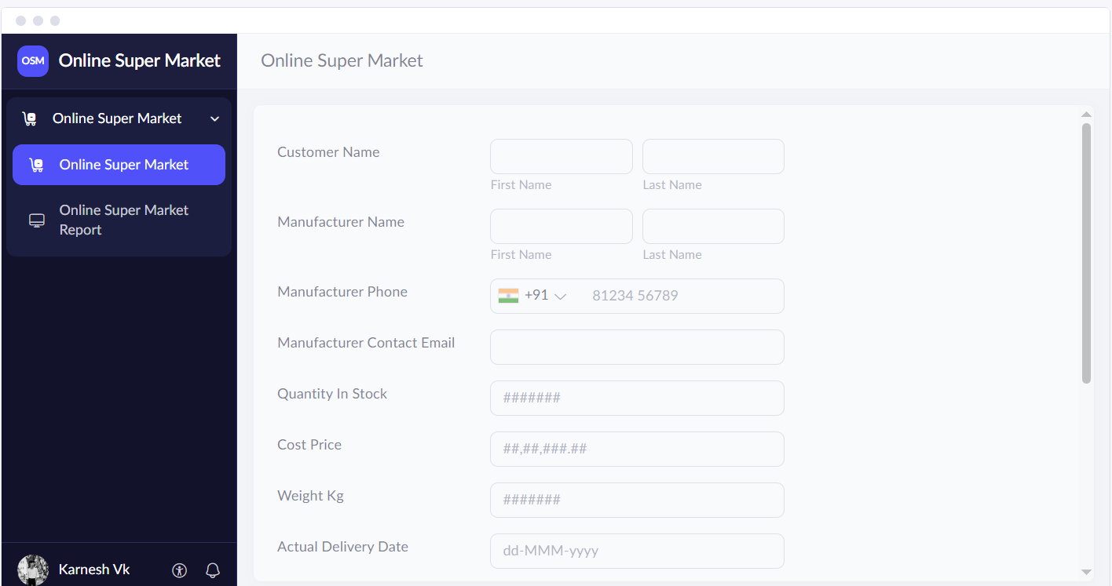
RESULT
Thus, a simple cloud-based Online Supermarket application was designed using Zoho Creator to demonstrate SaaS. The application helps manage customer details, classify supermarket items, and maintain order records through the cloud.

